**Noah**

**NOAH & the 2nd Coming**

* **Questions to be Answered**:
  + **How are you and I interested & connected to Noah?**

**(**Luke 17:26-27; JSM 1:41-43)

* + What was **Methuselah’s** unique calling? (Moses 8:1-2)
  + **How long did Noah preach** before the flood came? (Moses 8:17)
  + **Why would God destroy everyone** on the Earth?

(E. Maxwell; John Taylor quotes)

* + How is the story of Noah and the flood an example of **God's mercy and love**?
  + What do we learn about the importance of **Agency** from this story of the flood?
  + What was the **Spiritual Condition** and the specific **elements of Wickedness** at the time of Noah?
  + How did Noah **gather all the animals**? (Gen 6:20)
  + **How long** **did it rain** in order to flood the entire Earth? (Gen 7:4, 10,-12)
  + **How long** were they **on the Ark**? (Gen 7:11, 12, 24,; Gen 8:4, 14)
  + If the Garden of Eden was on the American Continent (Adam-Ondi-Ahman) then **how did they get over to the Middle East** where the stories of the Bible take place**?**
  + What was the **first thing** they did once they got off the Ark? (Gen 8:20; JST Gen 9:4-6)
  + What **Special instructions** did God give them once they arrived? (Gen 9:1,4/JST Gen 9:10-14)
  + How does Noah relate to the **2nd Coming**? (Matt 24:36-39; Luke 17:26-27; JSM 1:41-43)
  + What would you say the **biggest problem in society** at the time of Noah?
  + What is **the most significant thing** you have learned from your study of the story of Noah?
* **Elements of Wickedness**
  + - Marriage(Moses 8:13-15,21)
    - Violence (Moses 8:28-30)
    - Ignored Prophet (Moses 8:15, 20, 24)
* **2nd Coming**: (“As in the days of Noah”: Matt 24:36-39; Luke 17:26-27; JSM 1:41-43)

**Quoted References:**

**Pearl of Great Price**; Book of Moses ch. 8 <https://www.churchofjesuschrist.org/study/scriptures/pgp/moses/8?lang=eng>

**Book of Genesis** ch. 6-9 <https://www.churchofjesuschrist.org/study/scriptures/ot/gen/6?lang=eng>

**Joseph Smith Translation of the Bible**; Genesis 9:10-15 <https://www.churchofjesuschrist.org/study/scriptures/jst/jst-gen/9?lang=eng>

**Book of Mormon References:**

**3 Nephi 10:12:** And it was the [*a*more](https://abn.churchofjesuschrist.org/study/scriptures/bofm/3-ne/10?lang=eng#note12a) righteous part of the people who were saved, and it was they who received the prophets and stoned them not; and it was they who had not shed the blood of the saints, who were spared

<https://abn.churchofjesuschrist.org/study/scriptures/bofm/3-ne/10?lang=eng>

**2 Nephi 16: 8:** But behold, the righteous that hearken unto the words of the prophets, and destroy them not, but look forward unto Christ with *[a](https://abn.churchofjesuschrist.org/study/scriptures/bofm/2-ne/26?lang=eng" \l "note8a)*[steadfastness](https://abn.churchofjesuschrist.org/study/scriptures/bofm/2-ne/26?lang=eng" \l "note8a) for the signs which are given, notwithstanding all *[b](https://abn.churchofjesuschrist.org/study/scriptures/bofm/2-ne/26?lang=eng" \l "note8b)*[persecution](https://abn.churchofjesuschrist.org/study/scriptures/bofm/2-ne/26?lang=eng" \l "note8b)—behold, they are they which shall *[c](https://abn.churchofjesuschrist.org/study/scriptures/bofm/2-ne/26?lang=eng" \l "note8c)*[not perish](https://abn.churchofjesuschrist.org/study/scriptures/bofm/2-ne/26?lang=eng" \l "note8c).

<https://abn.churchofjesuschrist.org/study/scriptures/bofm/2-ne/26?lang=eng>

**3 Nephi 28:34-35**: And wo be unto him that will *[a](https://abn.churchofjesuschrist.org/study/scriptures/bofm/3-ne/28?lang=eng" \l "note34a)*[not hearken](https://abn.churchofjesuschrist.org/study/scriptures/bofm/3-ne/28?lang=eng" \l "note34a) unto the words of Jesus, and also to them whom he hath chosen and *[b](https://abn.churchofjesuschrist.org/study/scriptures/bofm/3-ne/28?lang=eng" \l "note34b)*[sent](https://abn.churchofjesuschrist.org/study/scriptures/bofm/3-ne/28?lang=eng" \l "note34b) among them; for whoso *[c](https://abn.churchofjesuschrist.org/study/scriptures/bofm/3-ne/28?lang=eng" \l "note34c)*[receiveth](https://abn.churchofjesuschrist.org/study/scriptures/bofm/3-ne/28?lang=eng" \l "note34c) not the words of Jesus and the words of those whom he hath sent receiveth not him; and therefore he will not receive them at the last day;

**35**And it would be better for them if they had not been born. For do ye suppose that ye can get rid of the justice of an *[a](https://abn.churchofjesuschrist.org/study/scriptures/bofm/3-ne/28?lang=eng" \l "note35a)*[offended](https://abn.churchofjesuschrist.org/study/scriptures/bofm/3-ne/28?lang=eng" \l "note35a) God, who hath been *[b](https://abn.churchofjesuschrist.org/study/scriptures/bofm/3-ne/28?lang=eng" \l "note35b)*[trampled](https://abn.churchofjesuschrist.org/study/scriptures/bofm/3-ne/28?lang=eng" \l "note35b) under feet of men, that thereby salvation might come?

<https://abn.churchofjesuschrist.org/study/scriptures/bofm/3-ne/28?lang=eng>

Extensive Quotes from “***Eternal Marriage Student Manual***”, 2003 for *Institute of Religion Classes* 234 and 235. Specific Chapters; Divorce (pg. 73-74); Happiness in Marriage (pg. 133-135); Marriage for Eternity (pg. 167-183)

<https://abn.churchofjesuschrist.org/study/manual/preparing-for-an-eternal-marriage?lang=eng>

Extensive Quotes from “***Preparing for an Eternal Marriage Teachers Manual***”, 2003 for *Institute of Religion Classes* 234 and 235. Specific Chapters; The Family: A Proclamation To The World (pg. 10-11).

<https://abn.churchofjesuschrist.org/study/manual/preparing-for-an-eternal-marriage?lang=eng>

**Teachings of Presidents of the Church: David O. McKay**, Ch. 15 *“Experiencing Happiness in Marriage”, pg. 143-145*

<https://www.churchofjesuschrist.org/study/manual/teachings-david-o-mckay/chapter-15?lang=eng>

**QUOTES:**

**President Spencer W. Kimball**

“Marriage is perhaps the most vital of all the decisions and has the most far-reaching effects, for it has to do not only with immediate happiness, but also with eternal joys. …

“… Marriage can be more an exultant ecstasy than the human mind can conceive. This is within the reach of every couple, every person” (“Oneness in Marriage,” Ensign, Mar. 1977, 3–4).

**President Ezra Taft Benson**

“As our family is our greatest source of joy in this life, so it may well be in the eternity” (in Conference Report, Apr. 1979, 48; or *Ensign,* May 1979, 33–34).

**President Boyd K. Packer**

“The ultimate purpose of all we teach is to unite parents and children in faith in the Lord Jesus Christ, that they are happy at home, sealed in an eternal marriage, linked to their generations, and assured of exaltation in the presence of our Heavenly Father” (in Conference Report, Apr. 1995, 8; or *Ensign,* May 1995, 8).

**Elder Bruce R. McConkie**

“There is nothing in this world as important as the creation and perfection of family units” (“Salvation Is a Family Affair,” *Improvement Era,* June 1970, 43–44).

“The whole aim and purpose of the gospel is to enable men and women﻿—united as one in the Lord﻿—to create for themselves eternal family units in eternity. Celestial marriage prepares us for the greatest joy and happiness known to mortals and for eternal life in the realms ahead” (in Conference Report, Oct. 1979, 82; or *Ensign,* Nov. 1979, 55).

**Elder James E. Faust**

“Happiness in marriage and parenthood can exceed a thousand times any other happiness” (in Conference Report, Oct. 1977, 14; or *Ensign,* Nov. 1977, 11).

**President Gordon B. Hinckley**

“Perhaps our greatest concern is with families. The family is falling apart all over the world. The old ties that bound together father and mother and children are breaking everywhere. We must face this in our own midst. There are too many broken homes among our own. The love that led to marriage somehow evaporates, and hatred fills its place. Hearts are broken; children weep. Can we not do better? Of course we can. It is selfishness that brings about most of these tragedies. If there is forbearance, if there is forgiveness, if there is an anxious looking after the happiness of one’s companion, then love will flourish and blossom.

“As I look to the future, I see little to feel enthusiastic about concerning the family in America and across the world. Drugs and alcohol are taking a terrible toll, which is not likely to decrease. Harsh language one to another, indifference to the needs of one another﻿—all seem to be increasing. There is so much of child abuse. There is so much of spouse abuse. There is growing abuse of the elderly. All of this will happen and get worse unless there is an underlying acknowledgment, yes, a strong and fervent conviction, concerning the fact that the family is an instrument of the Almighty. It is His creation. It is also the basic unit of society.

“I lift a warning voice to our people. We have moved too far toward the mainstream of society in this matter. Now of course there are good families. There are good families everywhere. But there are too many who are in trouble. This is a malady with a cure. The prescription is simple and wonderfully effective. It is love. It is plain, simple, everyday love and respect. It is a tender plant that needs nurturing. But it is worth all of the effort we can put into it” (in Conference Report, Oct. 1997, 94; or *Ensign,* Nov. 1997, 69).

“There may be now and again a legitimate cause for divorce. I am not one to say that it is never justified. But I say without hesitation that this plague among us, which seems to be growing everywhere, is not of God, but rather is the work of the adversary of righteousness and peace and truth” (in Conference Report, Apr. 1991, 97–98; or *Ensign,* May 1991, 74).

**Elder Boyd K. Packer**

“The single purpose of Lucifer is to oppose the great plan of happiness, to corrupt the purest, most beautiful and appealing experiences of life: romance, love, marriage, and parenthood [[2 Nephi 2:18](https://abn.churchofjesuschrist.org/study/scriptures/bofm/2-ne/2.18?lang=eng#p18); [28:20](https://abn.churchofjesuschrist.org/study/scriptures/bofm/2-ne/28.20?lang=eng#p20)]. The specters of heartbreak and guilt follow him about [[Alma 39:5](https://abn.churchofjesuschrist.org/study/scriptures/bofm/alma/39.5?lang=eng#p5); [Moroni 9:9](https://abn.churchofjesuschrist.org/study/scriptures/bofm/moro/9.9?lang=eng" \l "p9)]. Only repentance can heal what he hurts” (in Conference Report, Oct. 1993, 27–28; or *Ensign,* Nov. 1993, 21).

“The ultimate purpose of the adversary, who has ‘great wrath, because he knoweth that he hath but a short time,’ [[Revelation 12:12](https://abn.churchofjesuschrist.org/study/scriptures/nt/rev/12.12?lang=eng#p12)] is to disrupt, disturb, and destroy the home and the family. Like a ship without a rudder, without a compass, we drift from the family values which have anchored us in the past. Now we are caught in a current so strong that unless we correct our course, civilization as we know it will surely be wrecked to pieces” (in Conference Report, Apr. 1994, 24; or *Ensign,* May 1994, 19).

**Elder Neal A. Maxwell**

“When corruption had reached an agency-destroying point that spirits could not, in justice, be sent here”

(**Elder Neal A. Maxwell**, “We Will Prove Them Herewith [1982], 58; see also “The Flood Was an Act of Love” in Old Testament: Genesis-2 Samuel, pp. 55-56).

**John Taylor**

“Why did the Lord destroy the world? Was it an act of love? YES! The people were so wicked they would have transmitted their unrighteous natures and desires to their children. Someone may ask, “Is it right that a just God should sweep off so many people. Is that in accordance with mercy” YES! It was just to those spirits that had not received their bodies, and it was just and merciful too to those people guilty of the iniquity. Why? Because by taking away their earthly existence he prevented them from entailing their sins upon their posterity and degenerating them, and also prevented them from committing further acts of wickedness. (**John Taylor**, **“The Flood an Act of Love”**, Journal of Discourses 19:158-159.)

**Joseph Fielding Smith**

“The earth will be cleansed again. It was once baptized in water. When Christ comes, it will be baptized by fire and the power of the Holy Ghost. At the end of the world the earth will die; it will be dissolved, pass away, and then it will be renewed, or raised with a resurrection. It will receive its resurrection to become a celestial body, so that they of the celestial order may possess it forever and ever. Then it will shine forth as the sun and take its place among the worlds that are redeemed. When this time comes the terrestrial inhabitants will also be taken away and be consigned to another sphere suited to their condition. Then the words of the Savior will be fulfilled, for the meek shall inherit the earth. (**Joseph Fielding Smith**, **“Earth Baptized”** Doctrines of Salvation 1:87-88)

**Elder Joseph B. Wirthlin** of the Quorum of the Twelve Apostles noted:

“‘[In the United States the] parents of nearly 2,750 children separate or divorce each day. …

“‘Every day over 500 children ages 10 to 14 begin using illegal drugs, and over 1,000 start drinking alcohol. Nearly half of all middle-schoolers abuse drugs or alcohol or [become involved in immorality]’ [Louis S. Richman, “Struggling to Save Our Kids,” *Fortune,* 10 Aug. 1992, 34–35]. Data from other nations are equally alarming.

“These and many other ills of our society today have their source in the breakdown of the family. If Satan can weaken or destroy the loving relationships among members of families, he can cause more misery and more unhappiness for more people than he could in any other way” (in Conference Report, Apr. 1993, 85; or *Ensign,* May 1993, 69).

**President Gordon B. Hinckley**, then a counselor in the First Presidency, stated:

“‘Since 1960, the U.S. [has experienced] … a 560% increase in violent crime; a 419% increase in illegitimate births; a quadrupling in divorce rates; a tripling of the percentage of children living in single-parent homes; more than a 200% increase in the teenage suicide rate’ (William J. Bennett, “Quantifying America’s Decline,” *Wall Street Journal,* 15 Mar. 1993, p. A12). …

“One need not, of course, read statistics to recognize a moral decay that seems to be going on all about us” (in Conference Report, Oct. 1993, 76–77; or *Ensign,* Nov. 1993, [54, 59](https://abn.churchofjesuschrist.org/study/ensign/1993/11?lang=eng)).

**Elder Alexander B. Morrison,** then a member of the Seventy, wrote:

“Federal government statistics [for the United States] for 1993 [indicate that] … over 1.2 million babies were born outside of marriage (31% of all births, up from 28% only three years previously). …

“Nearly one in four pregnancies now ends in abortion, with approximately 1.6 million abortions performed in 1990 and more than 28 million abortions [since] 1973. …

“The number of divorces in America has increased by nearly 200 percent in the last thirty years; only about 50 percent of U.S. marriages now are first-time marriages. …

“The percent of children living in single-parent homes has more than tripled in the last three decades, to its current level of nearly 29 percent of all families with children. Approximately 90 percent of single-parent homes are fatherless. …

“The reported incidence of child abuse increased from 101 per 10,000 Americans in 1976 to 390 per 10,000 in 1990, an almost fourfold increase” (*Zion: A Light in the Darkness* [1997], 4–7).

**Elder Alexander B. Morrison,** then a member of the Seventy, wrote:

“In *The Atlantic Monthly* (April 1993), Barbara Defoe Whitehead pointed out that divorce or out-of-wedlock childbirth are transforming the lives of American children. …

* Children in single-parent families are two to three times as likely as children in two-parent families to have emotional and behavioral problems. …
* Children in single-parent families are more likely to drop out of high school, to get pregnant as teenagers, to abuse drugs, and to be in trouble with the law. More than seventy percent of all juveniles in state reform institutions in the United States come from fatherless homes. …
* The father-child bond is severely, often irreparably damaged in families disrupted by divorce or illegitimacy. Close to half of such children have not seen their father at all in the past year. Many fathers have simply vanished. …

“Barbara Whitehead has stated that ‘survey after survey shows that Americans are less inclined than they were a generation ago to value sexual fidelity, lifelong marriage, and parenthood as worthwhile personal goals. Motherhood no longer defines adult womanhood; equally important is the fact that fatherhood has declined as a norm for men …’ [“Dan Quayle Was Right,” *Atlantic Monthly,* Apr. 1993, 55–56]. …

“… No society can long survive that denigrates, demeans, and devalues fatherhood. Men who do not look upon fatherhood, preceded by an honorable marriage, as a sacred privilege and obligation, deny their own manliness and can never rise to their divine potential, either in this world or the next” (*Zion: A Light in the Darkness* [1997], 11–14, 18).

**Elder Eran A. Call,** then a member of the Seventy, said:

“The home is being threatened and challenged more today than ever before. Today less than half of the children born in the United States, and in many countries in the world, will spend their entire childhood in an intact family [see Barbara Defoe Whitehead, “Dan Quayle Was Right,” *Atlantic Monthly,* Apr. 1993, 47]. Infidelity, divorce, abortion, and abandoned homes are on the increase. The father is rapidly losing his traditional role as caregiver, breadwinner, protector, moral educator, and head of the family.

“During 1960 to 1990, a 30-year period, births outside of marriage in the United States increased 500 percent and divorce increased 400 percent [see David Blankenhorn, *Fatherless America: Confronting Our Most Urgent Social Problem* (1995)]” (in Conference Report, Oct. 1997, 37–38; or *Ensign,* Nov. 1997, 28).

**Statistics:**

Households and Families

* There were 37 million one-person households in 2021, or 28% of all U.S. households. In 1960, single-person households represented only 13% of all households.
* The number of families with their own children under age 18 in the household declined over the last two decades. In 2021, 40% of all U.S. families lived with their own children, compared to 44% in 2011 and 48% in 2001.

Marriage

* In 2021, 34% of adults age 15 and over had never been married, up from 23% in 1950.
* The estimated median age to marry for the first time was 30.4 for men and 28.6 for women in early 2021, up from ages 23.7 and 20.5, respectively, in 1947.
* In 2021, less than one-quarter (24%) of children under age 15 living in married-couple families had a stay-at-home mother, compared to 1% with a stay-at-home father.

Living Arrangements

* Some living arrangements differed by sex and age group in 2021. The percentage of men and women ages 18 to 24 that lived alone, about 5% each, did not significantly differ. More women than men in this age group lived with a spouse, 7% and 4%, respectively. The percentage of men ages 18 to 24 living alone was not significantly different from the percentage of men who lived with a spouse. A greater share of women (12%) than men (7%) this age also lived with an unmarried partner.
* Men and women ages 25 to 34 were more likely than their younger peers to live with a spouse or unmarried partner: one-third (33%) of men and 42% of women lived with a spouse in early 2021. But about the same share (17%) of both men and women of these ages lived with an unmarried partner. These patterns were likely related to the lower median age of women (28.6) than men (30.4) at first marriage.
* In 2021, more than one-half (58%) of adults ages 18 to 24 lived in their parental home, compared to 17% of adults ages 25 to 34.

For more data on families and living arrangements, visit [Families and Living Arrangements](https://www.census.gov/topics/families.html) at <[www.census.gov](https://www.census.gov/)>.

[**https://www.census.gov/newsroom/press-releases/2021/families-and-living-arrangements.html**](https://www.census.gov/newsroom/press-releases/2021/families-and-living-arrangements.html)

**United States marriage rate, 1900-2018  
Rate per 1,000 population**

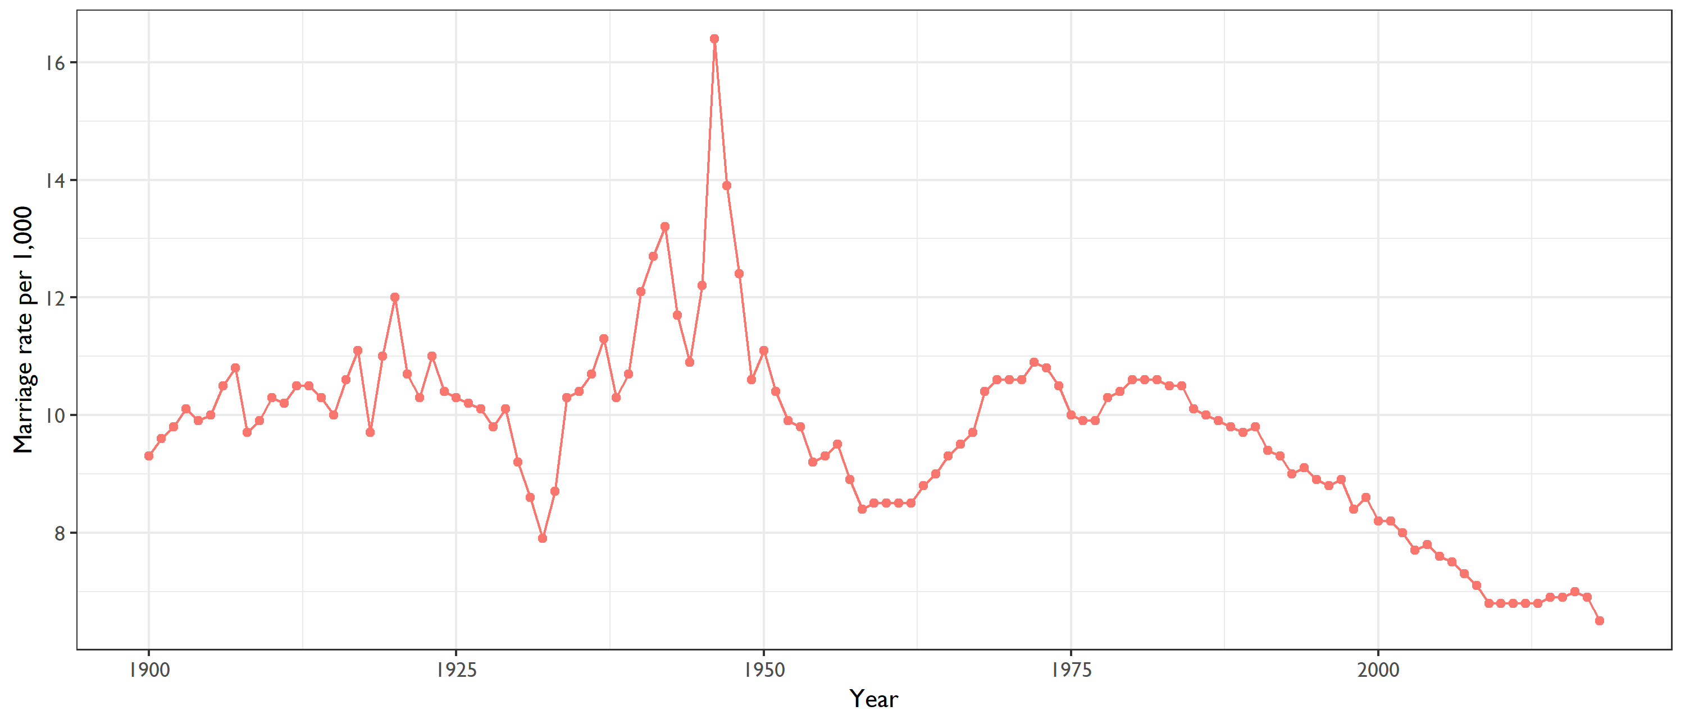

**United States marriage rate, 1900-2018**Rate per 1,000 population

[**https://www.jec.senate.gov/public/index.cfm/republicans/2020/4/marriage-rate-blog-test**](https://www.jec.senate.gov/public/index.cfm/republicans/2020/4/marriage-rate-blog-test)

[**https://www.cdc.gov/nchs/data/hestat/marriage_rate_2018/marriage_rate_2018.htm**](https://www.cdc.gov/nchs/data/hestat/marriage_rate_2018/marriage_rate_2018.htm)

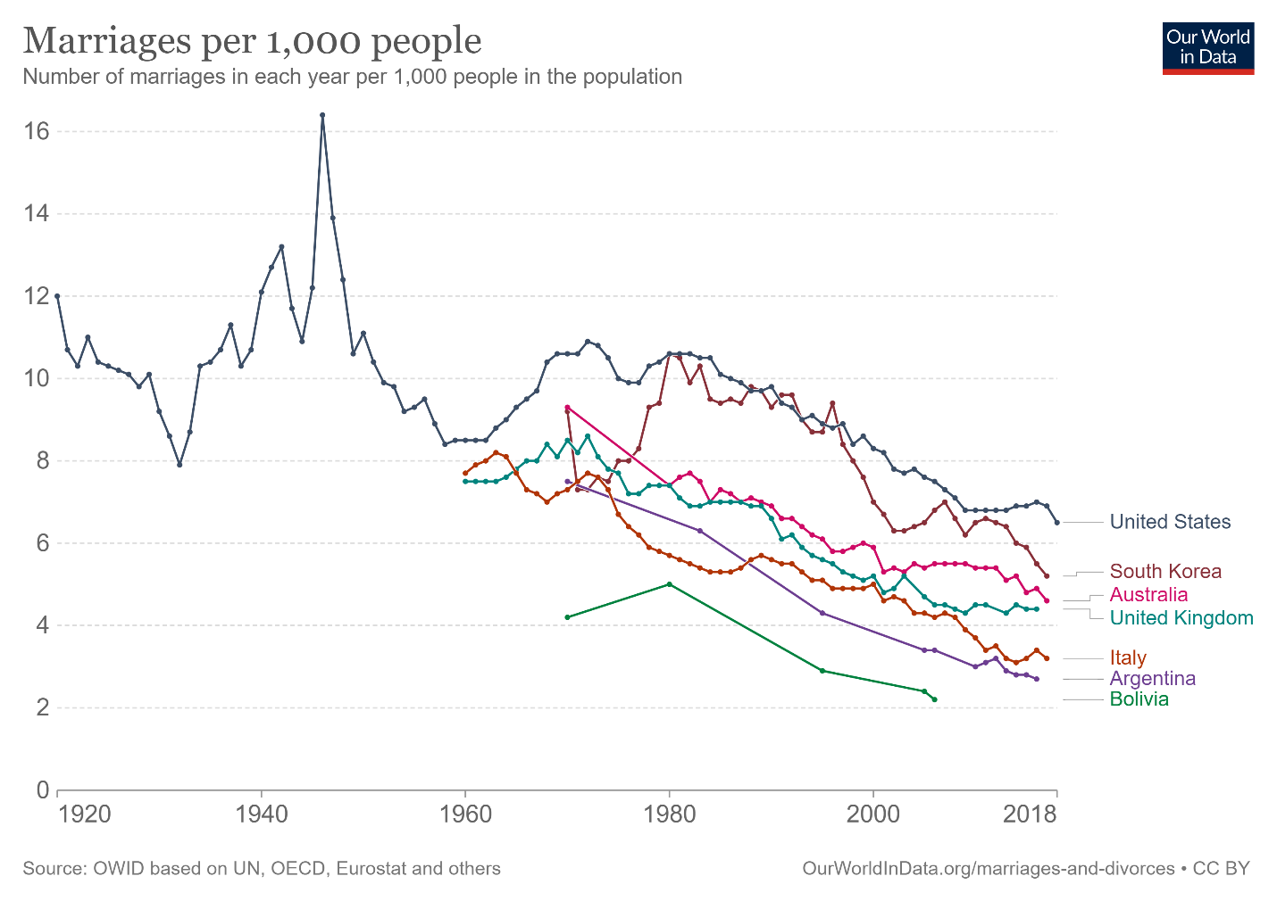

<https://ourworldindata.org/grapher/marriage-rate-per-1000-inhabitants?country=ARG~AUS~BOL~ITA~KOR~GBR~USA>