**Jerusalem the Eternal City**

Episode 2: THE HOLY LAND - JERUSALEM

**Questions about Jerusalem**

1. **Why** is the City of Jerusalem SO significant? (What makes it so important?)

2. Why do some people **Pray towards Jerusalem**?

3. Why do some refer to Jerusalem as the **Center of the Universe**?

4. Why is Jerusalem called **The Eternal City** or the **City of God**?

 5. What role will Jerusalem play in the **Future**?

 6. Have there ever been **LDS Missionaries** in the Holy Land?

7. How many times has the Holy Land been **dedicated** by an Apostle or Prophet?

**Helpful Definitions:**

**Diaspora**, (Greek: “Dispersion”) Hebrew Galut (Exile), **the dispersion of Jews among the Gentiles after the Babylonian Exile** (587 BC) or the aggregate of Jews or Jewish communities scattered “in exile” outside Palestine or present-day Israel.

*“The Holy City”* with Stanford Olsen & the Mormon Tabernacle Choir:

<https://youtu.be/5PAc3krFyQA>

**Jerusalem Episode 2**

* Evening View: A true highlight after flying there all day!
  + Quote: “Jerusalem mentioned more than 840 times in the Bible… 70 other titles…and more scriptural detail than for any other city in the world.” (Jerusalem, The Eternal City, pg. 10)
  + “No other city has so shaped this earth’s history and destiny as has Jerusalem…greatest empires, nations, and individuals have concerned themselves with Jerusalem…Egyptians…Babylonians, Persians, Greeks, Romans, Byzantines, Muslims, Crusaders, Turks, British, Arabs, and Israelis have all paraded through the pages of Jerusalem’s history…” (*Jerusalem, the Eternal City*, pg. 1)
  + “Pivotal personalities…Abraham, David, Solomon, Isaiah, Lehi, Nephi, Jeremiah, Alexander the Great, Pompey, Cleopatra, Herod, Peter, Paul, Titus, Constantine, Muhammad, Richard the Lion-hearted, Maimonides, Saladin, Suleiman the Magnificent, and a host of others...” (*Jerusalem, the Eternal City*, pg. 1)
  + “The greatest person ever born in this world, Jesus Christ, brought about in Jerusalem the greatest events and the greatest contributions of all time: His atoning sacrifice and resurrections from the dead, the events that have immortalized the City and made the name Jerusalem forever holy.” (*Jerusalem, the Eternal City*, pg. 1)
  + “An impressive array of buildings has been erected in the city of Jerusalem over the ages…palaces, synagogues, churches, shrines, monasteries, convents, mosques, madrasas, yeshivas, and other centers of government, learning, and worship. The most influential of them all was the Temple of God, which stood for a thousand years on the eastern hill of Jerusalem, the “Mountain of the Lord…” (*Jerusalem, The Eternal City*, pg. 4)
  + Many voices have sung the praises of Jerusalem. The rabbis, for example, wrote that there is no beauty like that of Jerusalem (Avot de Rabbi Nathan 28, 85). Of the ten measures of beauty that came down to the world, Jerusalem received nine (Kiddushin 49b). Whoever has not seen Jerusalem in all its splendor has never seen a beautiful city in his life (Succah 51b).” (*Jerusalem, The Eternal City*, pg. 4)
  + “The history of Jerusalem is a mixture of glories and catastrophes. In almost all cases, powerful religious feelings were present in the shaping of events.” Saul B. Cohen wrote: “No other city in the world has been subject to such intense competition for control as Jerusalem during its 4,000 years of recorded history…Thomas Idinopulos noted that “nothing sacralizes stones like blood, and Jerusalem is a city founded on sanctity, sacrifice, and blood. A lot of blood.” In fact, as Barbara Tuchman asserted in the Bible and Sword, “More blood has been shed for Jerusalem than any other spot on earth.”” (*Jerusalem, The Eternal City*, pg. 4)
  + “With Jerusalem’s sanctification,” wrote Norman Kotker, “has come bloodshed—the sacrifice of animals at the temple, the sacrifice of Christ, the endless sacrifice of its citizens striving to defend the holy city against the attacks of enemies…Abraham sacrificed there, the victim to be his own son Isaac, until God saved the boy by sending a ram as a substitute. And then, it is said, God Himself performed a sacrifice at Jerusalem, to Himself, of Himself, the victim, His own son Jesus” (*Jerusalem, The Eternal City*, pg. 4)
  + “Many people have prayed toward Jerusalem and toward the Temple. Millions over the centuries have revered the City as the center of the earth, believing that the omphalos, or umbilical cord, connecting heaven and earth attached directly to the Foundation Stone of the Temple or to Golgotha or to the Holy Sepulcher. Earth was considered the center of the universe… (see Midrash quote and diagram below)

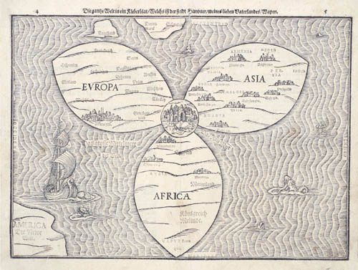

* + “Earth was considered the center of the universe; the Holy Land was the center of the earth; Jerusalem was the center of the Holy Land; the Temple was the center of Jerusalem; the Holy of Holies was the center of the Temple; the Ark with its mercy seat of God was the center of the Holy of Holies; God, therefore, was at the center of centers. The land of Israel lies in the center of the world; Jerusalem lies in the center of the land of Israel; the holy precinct lies in the center of Jerusalem; the Temple building lies in the center of the holy precinct; the ark of the covenant lies in the center of the Temple building; the Sacred Rock, however, lies before the ark of the covenant, for from it the world was founded.”  *(From* ***Midrash*** *Tanhuma, as cited from Jeremias in Finegas, Archaeology of the New Testament, 272)*

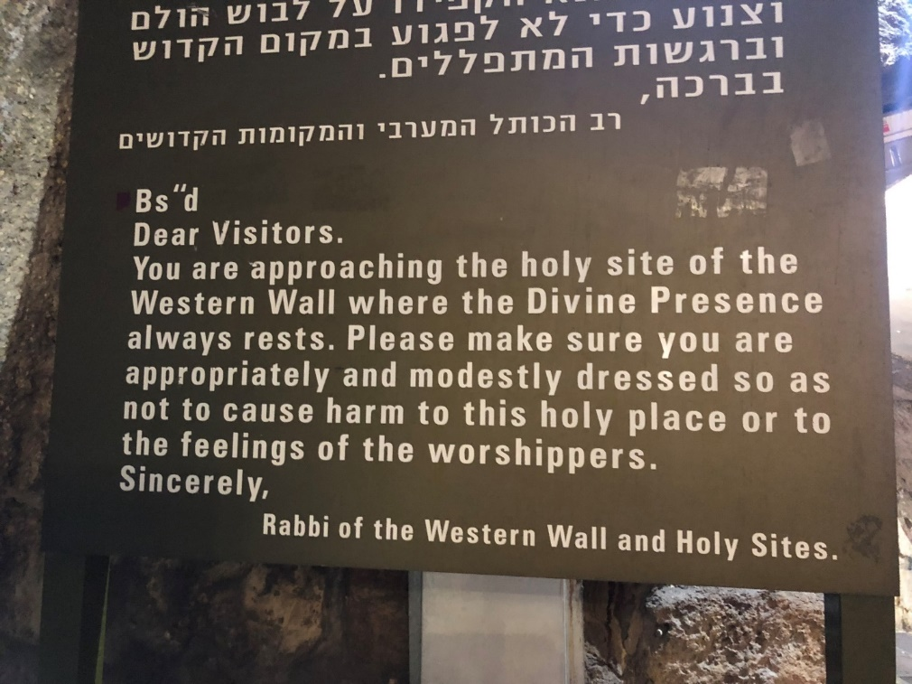

* + “…the spiritual attachment of the Jewish people to Jerusalem remains unbroken. It is a bond created by covenant between God and Abraham, which no amount of suffering or sacrifice can sever. During the Diaspora, wherever the Jews found themselves on the face of the earth, the Jews prayed for the return to Zion, the biblical synonym for Jerusalem…” (*Jerusalem Countdown, A Warning to the World*, pg. 48)
  + “…Their synagogues, wherever in the world they are built, were built facing Jerusalem. When the Jew built a house, part of the wall would be left unfinished, symbolizing the fact it was temporary dwelling—until the owner could return to Jerusalem...” (*Jerusalem Countdown, A Warning to the World*, pg. 48)
  + “…Jerusalem is now and will be in the future the Center of the Universe. There will be no world peace until there is peace in Jerusalem. Jerusalem is like no city on the face of the earth because Jerusalem is nothing less than the City of God.” (*Jerusalem Countdown, A Warning to the World*, pg. 48)
  + “Jerusalem is seen by many as the site of the Final Battle, when the political entities representing the forces of good and the forces of evil will clash in a last confrontation to end the world. According to all three faiths (Christianity, Judaism, and Islam), Jerusalem will also be the scene of the Final Judgement at the Kidron Valley, which is so called the Valley of Jehoshaphat (the symbolic name meaning “Jehovah will judge”)…” (*Jerusalem, The Eternal City*, pg. 5-6)
  + “Tradition has identified Jerusalem as the location of the great resurrections; those buried in the Holy City, especially on the Mount of Olives and the Temple Mount, will be first to resurrect (the reason for Jewish, Christian, and Muslim cemeteries there). Jerusalem, the navel of the earth and the light of the world, is destined to become the metropolis of all countries, a capital for all the world…” (*Jerusalem, The Eternal City*, pg. 5-6)
  + “For untold millions Jerusalem has been not an appendage to their life but the heart and soul of their existence…the people of Jerusalem drag the past forward into their homes and hearts, so that the past becomes a part of them, uniting them, justifying them in their grievances, instilling hope for the future…Jerusalem is an eschatological city, always in the end-time, awaiting any moment the cataclysm that will inaugurate the New Age.” (*Jerusalem, The Eternal City*, pg. 5-6)
  + Pres. Nelson - The Second Coming

“The Lord will return to the land that He made holy by His mission there in mortality. In triumph, **He will come again to Jerusalem**. In royal robes of red to symbolize His blood, which oozed from every pore, **He shall return to the Holy City** (see D&C 133:46–48). There and elsewhere, “the glory of the Lord shall be revealed, and all flesh shall see it together” (Isaiah 40:5; see also D&C 101:23). His “name shall be called Wonderful, Counsellor, The mighty God, The everlasting Father, The Prince of Peace” (Isaiah 9:6). …He will **govern from two world capitals**: **one in old Jerusalem** (see Zechariah 14) and the other in the **New Jerusalem** “built upon the American continent” (Articles of Faith 1:10). From these centers He will direct the affairs of His Church and kingdom. **Another temple will yet be built in Jerusalem**. From that temple He shall reign forever as Lord of Lords. Water will issue from under the temple. Waters of the Dead Sea will be healed. (See Ezekiel 47:1–8.)...” “In that day He will bear new titles and be surrounded by special Saints. He will be known as “Lord of lords, and King of kings: and they that [will be] with him [will be those who] are called, and chosen, and faithful” (Revelation 17:14) to their trust here in mortality. Then He “shall reign for ever and ever” (Revelation 11:15). The earth will be returned to its paradisiacal state and be made new. There will be a new heaven and a new earth (see Revelation 21:1; Ether 13:9; D&C 29:23–24). It is our charge—it is our privilege—to help prepare the world for that day.” [200 Years of Light: 1820–2020, The Future of the Church: Preparing the World for the Savior’s Second Coming] by President Russell M. Nelson, April 2020 Ensign

* + **Orson Hyde Seeing Jerusalem for 1st Time:**

Elder Orson Hyde wrote an account of his travels in the Holy Land in a letter to his fellow members of the Quorum of the Twelve Apostles.

**Trieste, January 1, 1842**

Dear Brethren of the Twelve,

As a member…of your honorable quorum, bearing , in common with you, the responsibility under which HEAVEN has laid us, to spread the word of life among the perishing nations of the earth, allow me to say, that, on the 21st of October last, “My natural eyes, for the first time beheld” Jerusalem; and as I gazed upon it and its environs, the mountains and hills by which it is surrounded, and considered, that this is the stage upon which so many scenes of wonders have been acted, where prophets were stoned, and the Saviour of sinners slain, a storm of commingled emotions suddenly arose in my breast, the force of which was only spent in a profuse shower of tears… “As I stood upon this almost sacred spot and gazed upon the surrounding scenery, and contemplated the history of the past in connection with the prophetic future, I was lost in wonder and admiration, and felt almost ready to ask myself---Is it a reality that I am here gazing upon this scene of wonders? Or am I carried away in the fanciful reveries of a night vision?...“Is that city which I now look down upon really Jerusalem, whose sins and iniquity swelled the Savior's heart with grief, and drew so many tears from his pitying eye? Is that small enclosure in the valley of Kedron, where the boughs of those lonely olives are waving their green foliage so gracefully in the soft and gentle breeze, really the garden of Gethsemane, where powers infernal poured the flood of hells dark gloom around the princely head of the immortal Redeemer? Oh, yes! The fact that I entered the garden and plucked a branch from an olive, and now have that branch to look upon demonstrates that all was real. There, there is the place where the Son of the Virgin bore our sins and carried our sorrows---there the angels gazed and shuddered at the sight, waiting for the order to fly to his rescue; but no such order was given. The decree had passed in heaven, and could not be revoked, that he must suffer, that he must bleed, and that he must die. What bosom so cold, what feelings so languid, or what heart so unmoved that can withhold the humble tribute of a tear over this forlorn condition of the Man of sorrows?”

(*Times and Seasons* 3 [15 July 1842]: 847, 850-53, Jerusalem, The Eternal City, p. 508-9)

* + **Dedications of the Holy Land**

1842—Orson Hyde

1873—George A. Smith w/Lorenzo Snow

1898—Anthon H. Lund

1902—Francis L. Lyman

1921—David O. McKay

1927—James E. Talmage

1933—John A. Widstoe

* + **Missionaries in Israel**

1884—Jacob Sporry (Ricks College)

1887—Joseph M. Tanner

1895—John A. Clark

**Elder Clark** died of Typhoid Fever. The family decided to leave the body in Israel (Haifa). In 1948, when Israel was made a state, many wanted a presence there. But in order to do so, you must be able to prove you had a presence there prior to 1948. Because Elder Clark had been buried there, the Church was able to establish a presence there and build the BYU Jerusalem Center!

* + **3 Nephi 20:29-37, 46**

29 And I will remember the covenant which I have made with my people; and I have covenanted with them that I would gather them together in mine own due time, that I would give unto them again the land of their fathers for their inheritance, which is the land of Jerusalem, which is the promised land unto them forever, saith the Father.

30 And it shall come to pass that the time cometh, when the fulness of my gospel shall be preached unto them;

31 And they shall believe in me, that I am Jesus Christ, the Son of God, and shall pray unto the Father in my name.

32 Then shall their watchmen lift up their voice, and with the voice together shall they sing; for they shall see eye to eye.

33 Then will the Father gather them together again, and give unto them Jerusalem for the land of their inheritance.

34 Then shall they break forth into joy—Sing together, ye waste places of Jerusalem; for the Father hath comforted his people, he hath redeemed Jerusalem.

35 The Father hath made bare his holy arm in the eyes of all the nations; and all the ends of the earth shall see the salvation of the Father; and the Father and I are one.

**36**And then shall be brought to pass that which is written: Awake, awake again, and put on thy strength, O Zion; put on thy beautiful garments, O Jerusalem, the holy city, for henceforth there shall no more come into thee the uncircumcised and the unclean.

**37**Shake thyself from the dust; arise, sit down, O Jerusalem; loose thyself from the bands of thy neck, O captive daughter of Zion.

**46**Verily, verily, I say unto you, all these things shall surely come, even as the Father hath commanded me. Then shall this covenant which the Father hath covenanted with his people be fulfilled; and then shall Jerusalem be inhabited again with my people, and it shall be the land of their inheritance.

***“The Holy City”***

Last night I lay asleeping  
There came a dream so fair  
I stood in old Jerusalem  
Beside the temple there  
I heard the children singing  
And ever as they sang  
Methought the voice of Angels  
From Heaven in answer rang  
"Jerusalem, Jerusalem!  
Lift up your gates and sing,  
Hosanna in the highest.  
Hosanna to your King!"

And then methought my dream was chang'd

The streets no longer rang

Hushed were the glad Hosannas

The little children sang

The sun grew dark with mystery

The morn was cold and chill

As the shadow of a cross arose

Upon a lonely hill

"Jerusalem, Jerusalem!

Hark! How the Angels sing,

Hosanna in the highest,

Hosanna to your King!""

No need of moon or stars by night

Or sun to shine by day

It was the New Jerusalem

That would not pass away

"Jerusalem! Jerusalem

Sing for the night is o'er

Hosanna in the highest

Hosanna for evermore!"